**Lab Assignment – 1**

1. Create ASP.NET page to accept a name from the user and display welcome message.

**Que1.aspx Code**

<%@ Page Language="C#" AutoEventWireup="true" CodeBehind="Que1.aspx.cs" Inherits="Demo.App_Start.Bhoomi_Mam.Assignments.AS1.Que1" %>

<!DOCTYPE html>

<html xmlns="http://www.w3.org/1999/xhtml">

<head runat="server">

<title></title>

</head>

<body>

<form id="form1" runat="server">

<div>

Name&nbsp; :&nbsp;&nbsp;

<asp:TextBox ID="Name" runat="server"></asp:TextBox>

<br />

<br />

<asp:Button ID="clickme" runat="server" OnClick="Button1_Click" Text="Click Me" />

<br />

<br />

<asp:Label ID="Label1" runat="server"></asp:Label>

</div>

</form>

</body>

</html>

**Que1.aspx.cs Code**

using System;

using System.Collections.Generic;

using System.Linq;

using System.Web;

using System.Web.UI;

using System.Web.UI.WebControls;

namespace Demo.App_Start.Bhoomi_Mam.Assignments.AS1

{

public partial class Que1 : System.Web.UI.Page

{

protected void Page_Load(object sender, EventArgs e)

{

}

protected void Button1_Click(object sender, EventArgs e)

{

String name = Name.Text;

Label1.Text = name;

}

}

}

**Output Screenshot:**

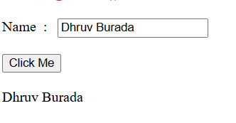

1. Create ASP.NET page to generate the Temperature Conversion.

**Que2.aspx Code**

<%@ Page Language="C#" AutoEventWireup="true" CodeBehind="Que2.aspx.cs" Inherits="Demo.App_Start.Bhoomi_Mam.Assignments.AS1.Que2" %>

<!DOCTYPE html>

<html xmlns="http://www.w3.org/1999/xhtml">

<head runat="server">

<title></title>

</head>

<body>

<form id="form1" runat="server">

<div>

<asp:Label ID="Label1" runat="server" Text="Temp in Celcius : "></asp:Label>

<asp:TextBox ID="temp" runat="server"></asp:TextBox>

&nbsp;&nbsp; F<br />

<br />

<asp:Label ID="tempoutput" runat="server"></asp:Label>

<br />

<br />

<asp:Button ID="Convert" runat="server" Text="Convert" OnClick="Convert_Click" />

</div>

</form>

</body>

</html>

**Que2.aspx.cs Code**

using System;

using System.Collections.Generic;

using System.Linq;

using System.Web;

using System.Web.UI;

using System.Web.UI.WebControls;

namespace Demo.App_Start.Bhoomi_Mam.Assignments.AS1

{

public partial class Que2 : System.Web.UI.Page

{

protected void Page_Load(object sender, EventArgs e)

{

}

protected void Convert_Click(object sender, EventArgs e)

{

float fahrenheit = float.Parse(temp.Text);

float celsius = (fahrenheit - 32) * 5 / 9;

tempoutput.Text = celsius.ToString();

}

}

}

**Output Screenshot:**

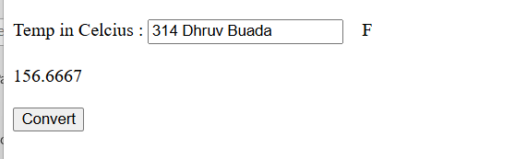

1. Create a component that receives two numbers from the user through a Web Form, and based on the user’s selection it performs algebraic operations on the two numbers and returns the result to the Web Form. The result should be displayed in the Web Form.

**Que3.aspx Code**

<%@ Page Language="C#" AutoEventWireup="true" CodeBehind="Que3.aspx.cs" Inherits="Demo.App_Start.Bhoomi_Mam.Assignments.AS1.WebForm1" %>

<!DOCTYPE html>

<html xmlns="http://www.w3.org/1999/xhtml">

<head runat="server">

<title></title>

</head>

<body>

<form id="form1" runat="server">

<div>

Num 1 :&nbsp;&nbsp;

<asp:TextBox ID="num1" runat="server"></asp:TextBox>

<br />

<br />

Num 2 :&nbsp;&nbsp;

<asp:TextBox ID="num2" runat="server"></asp:TextBox>

<br />

<br />

<asp:RadioButton ID="add" runat="server" Text="Add" GroupName="ArithmaticOptions" OnCheckedChanged="add_CheckedChanged" />

<asp:RadioButton ID="subs" runat="server" Text="Substract" GroupName="ArithmaticOptions" />

<asp:RadioButton ID="mul" runat="server" Text="Multiply" GroupName="ArithmaticOptions"/>

<asp:RadioButton ID="div" runat="server" Text="Divide" GroupName="ArithmaticOptions" />

<asp:RadioButton ID="modu" runat="server" Text="Modulo" GroupName="ArithmaticOptions"/>

<br />

<br />

<asp:Button ID="Calculate" runat="server" OnClick="Button1_Click" Text="Button" />

<br />

<br />

<asp:Label ID="arithmaticoutput" runat="server" Text=""></asp:Label>

</div>

</form>

</body>

</html>

**Que3.aspx.cs Code**

using System;

using System.Collections.Generic;

using System.Linq;

using System.Web;

using System.Web.UI;

using System.Web.UI.WebControls;

namespace Demo.App_Start.Bhoomi_Mam.Assignments.AS1

{

public partial class WebForm1 : System.Web.UI.Page

{

protected void Page_Load(object sender, EventArgs e)

{

}

protected void Button1_Click(object sender, EventArgs e)

{

float a = float.Parse(num1.Text);

float b = float.Parse(num2.Text);

float c =0;

if(add.Checked)

{

c = a + b;

}

else if(subs.Checked)

{

c = a - b;

}

else if(mul.Checked)

{

c = a * b;

}

else if (div.Checked)

{

c = a/b;

}

else if(modu.Checked)

{

c = a % b;

}

else

{

arithmaticoutput.Text = "Please Select Any of the One Option";

}

arithmaticoutput.Text = c.ToString();

}

protected void add_CheckedChanged(object sender, EventArgs e)

{

}

}

}

**Output Screenshot:**

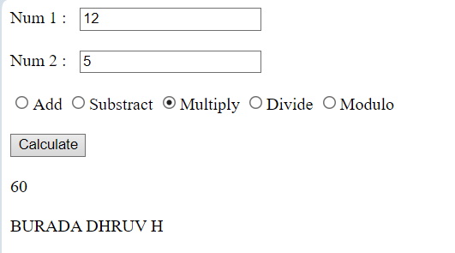

1. **Create ASP.NET page to demonstrate “AutoPostBack” property for controls available.**

**Que4.aspx**

<%@ Page Language="C#" AutoEventWireup="true" CodeBehind="Que4.aspx.cs" Inherits="Demo.App_Start.Bhoomi_Mam.Assignments.AS1.Que4" %>

<!DOCTYPE html>

<html xmlns="http://www.w3.org/1999/xhtml">

<head runat="server">

<title></title>

</head>

<body>

<form id="form1" runat="server">

<div>

<asp:Label ID="Label1" runat="server" Text="BURADA DHRUV H"></asp:Label>

<br />

</div>

<asp:ListBox ID="ListBox1" runat="server" AutoPostBack="True">

<asp:ListItem>Hemanshi</asp:ListItem>

<asp:ListItem>Mayur</asp:ListItem>

<asp:ListItem>Dhruv</asp:ListItem>

</asp:ListBox>

<br />

<br />

<asp:Label ID="item" runat="server"></asp:Label>

</form>

</body>

</html>

**Que4.aspx.cs**

using System;

using System.Collections.Generic;

using System.Linq;

using System.Web;

using System.Web.UI;

using System.Web.UI.WebControls;

namespace Demo.App_Start.Bhoomi_Mam.Assignments.AS1

{

public partial class Que4 : System.Web.UI.Page

{

protected void Page_Load(object sender, EventArgs e)

{

item.Text = ListBox1.SelectedValue;

}

}

}

**Output Screenshot:**

